**Brady Accuweather App Deployment in Azure**

First I created an app service to – bradydemo please find the below screen shot.

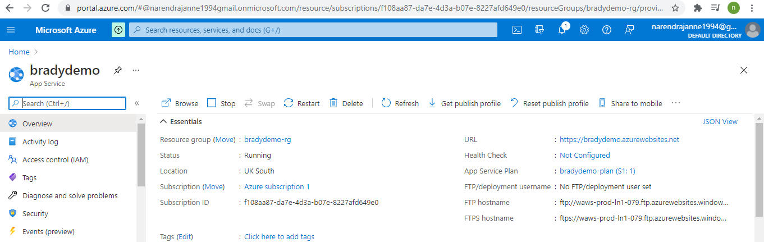

And resource group - bradydemo-rg

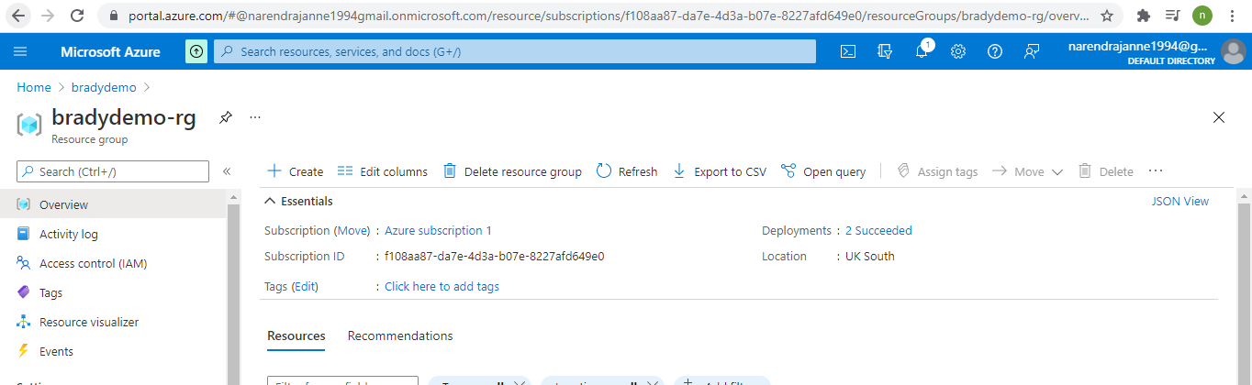

Resource group plan created bradydemo-plan

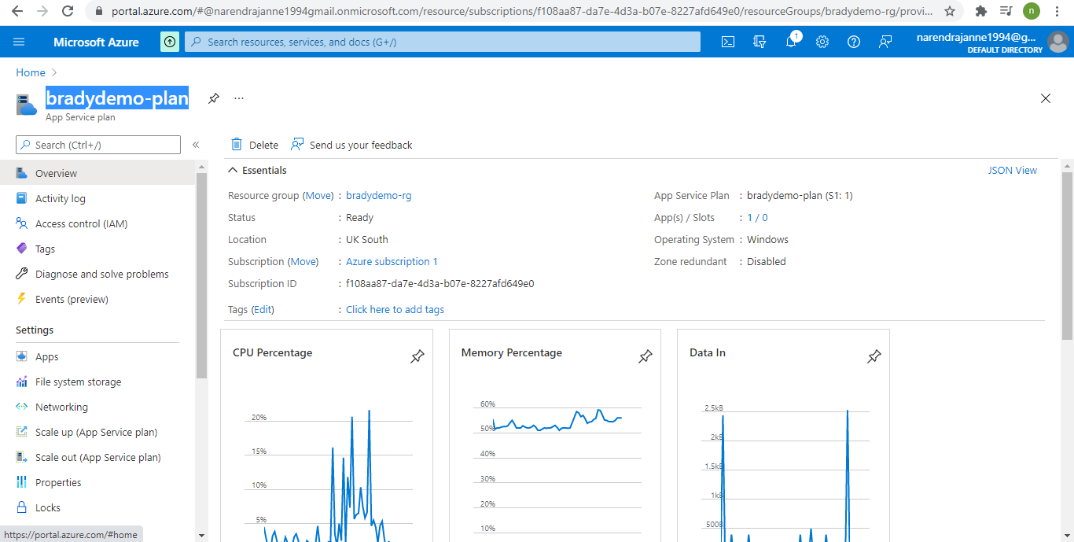

Application insight created – bradydemo

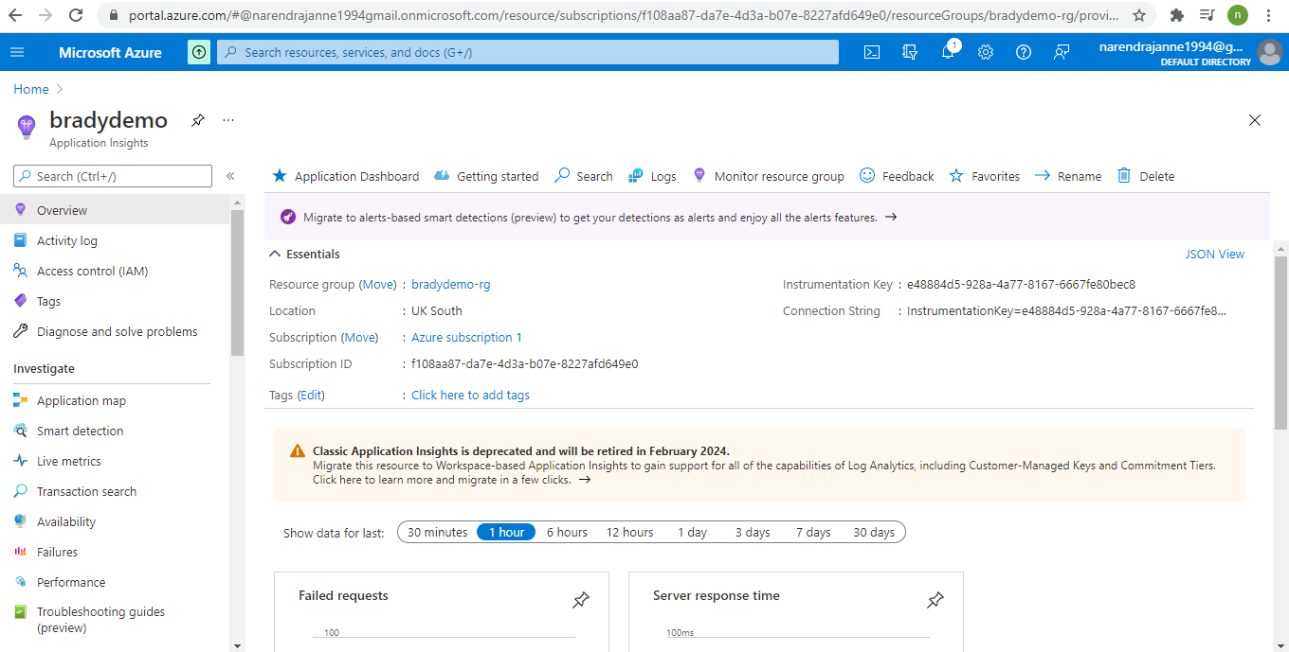

DevOps starter created – bradydemo with the application end point [https://bradydemo.azurewebsites.net](https://bradydemo.azurewebsites.net/)

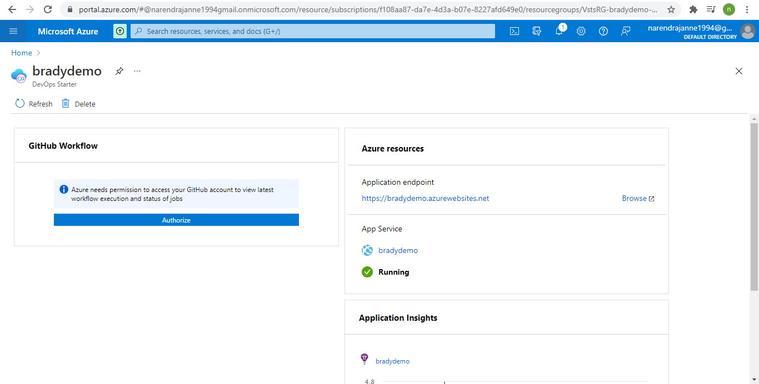

Once end point successfully setup

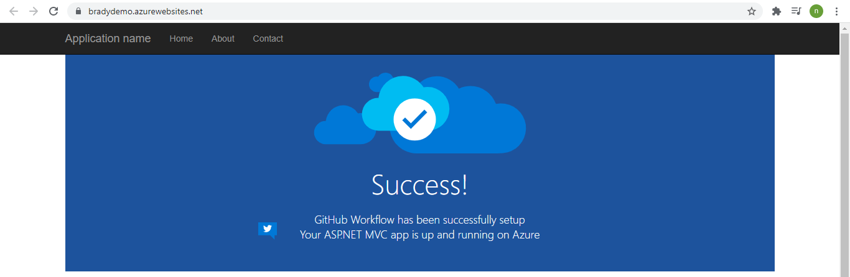

Please find the GitHub bradydemo repository it has deployment files and testing files which I have used for this project for basic general testing.

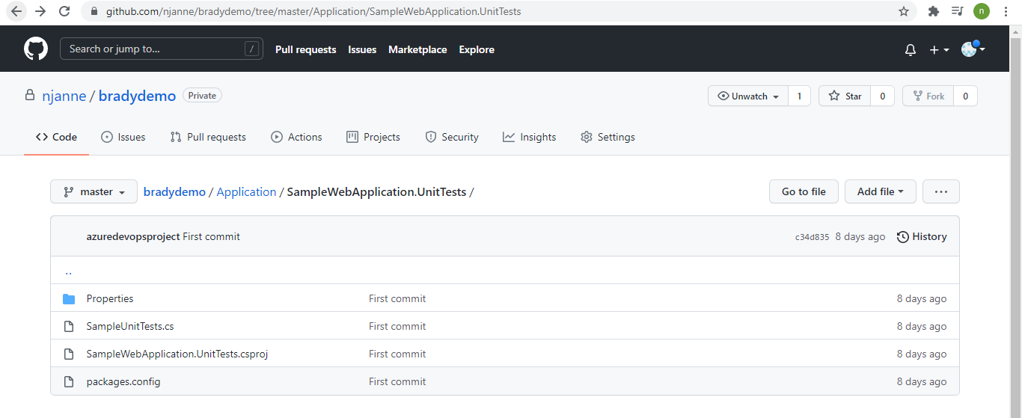

You can see the devops-starter-workflow.yml file in the bradydemo/.github/workflows/devops-starter-workflow.yml in master branch.

Created the accuweather api key for cities and locations and used the same

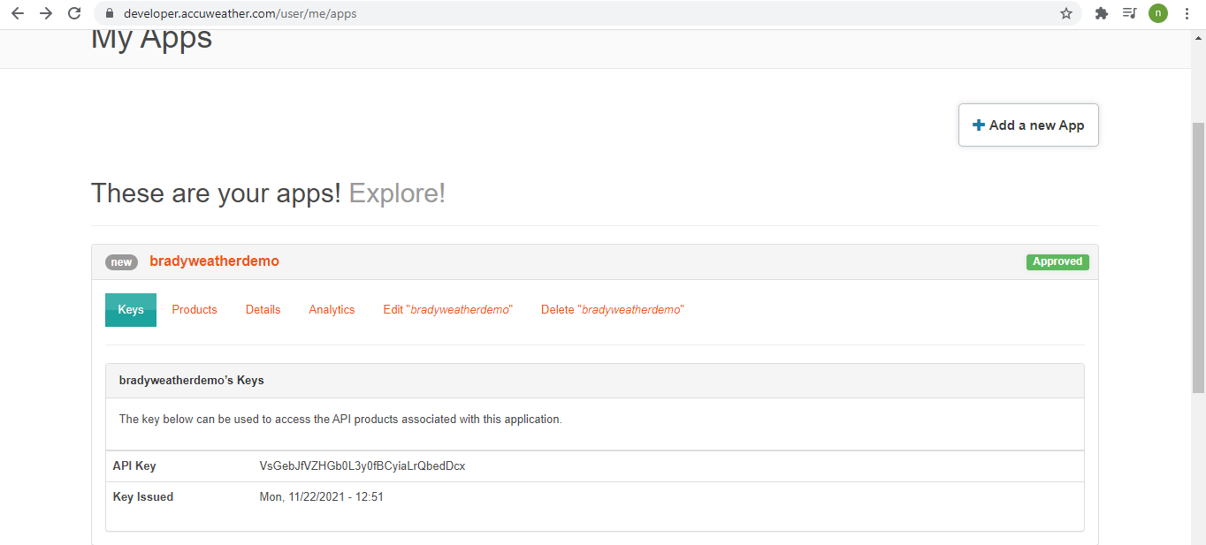

Used the same api key to get the cities and make noted the api key further purpose. Please find the response which I got.

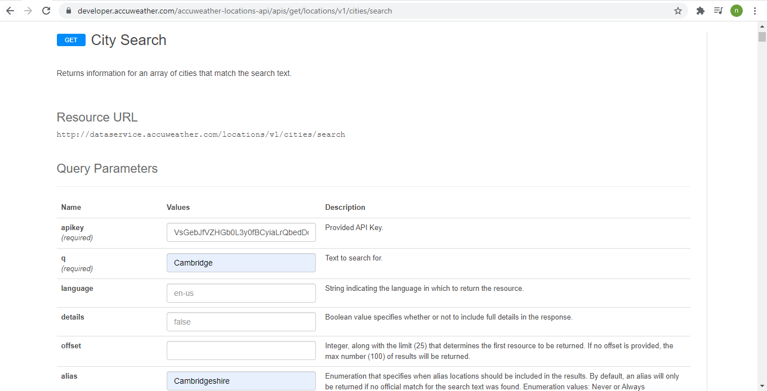

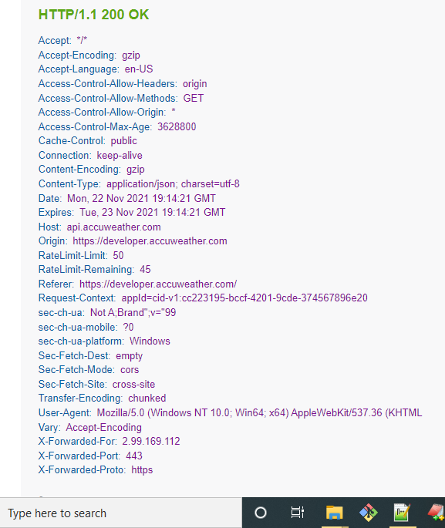

**By using the app service get publish option I published the weather app from the visual studio code.**

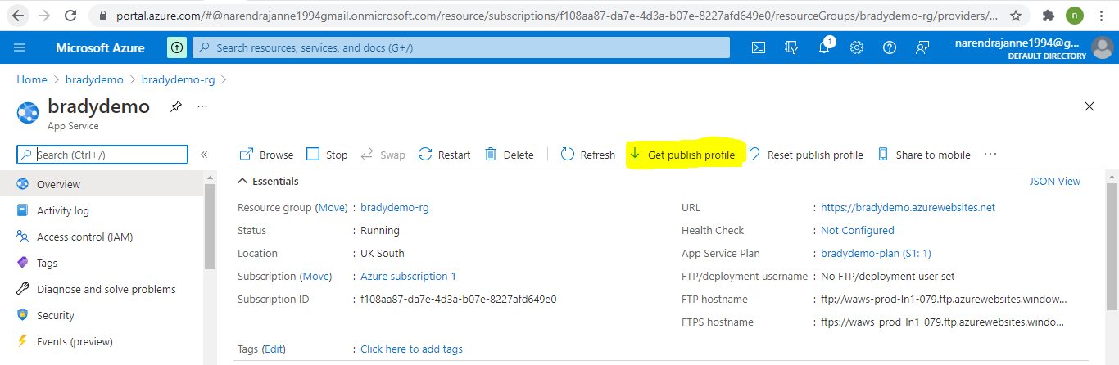

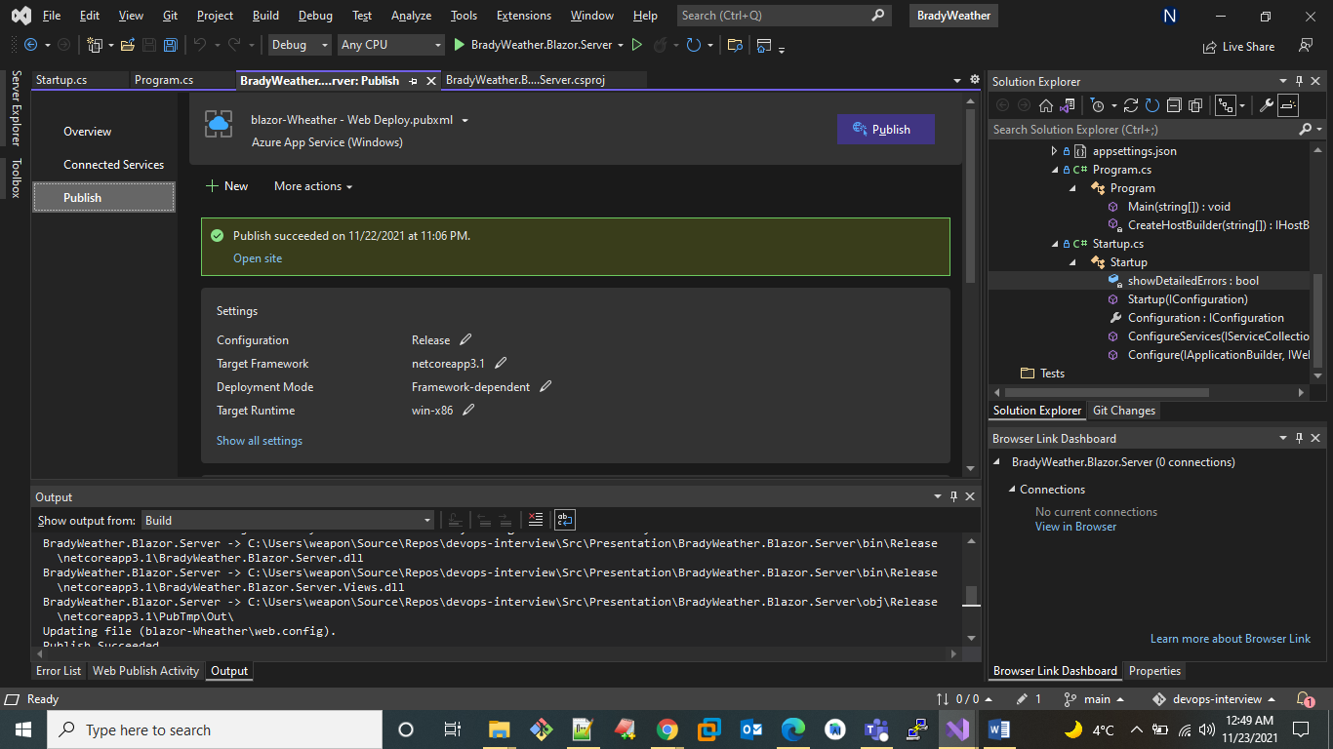

**Endpoint -** [BradyWeather.Blazor.Server (blazor-wheather.azurewebsites.net)](https://blazor-wheather.azurewebsites.net/) in response of publish to public I can able to access it through the browser and see the page as below.

